What is an A* Algorithm?
It is a searching algorithm that is used to find the shortest path between an initial and a final point.
It is a handy algorithm that is often used for map traversal to find the shortest path to be taken. A* was initially designed as a graph traversal problem, to help build a robot that can find its own course. It still remains a widely popular algorithm for graph traversal.
It searches for shorter paths first, thus making it an optimal and complete algorithm. An optimal algorithm will find the least cost outcome for a problem, while a complete algorithm finds all the possible outcomes of a problem.
Another aspect that makes A* so powerful is the use of weighted graphs in its implementation. A weighted graph uses numbers to represent the cost of taking each path or course of action. This means that the algorithms can take the path with the least cost, and find the best route in terms of distance and time.
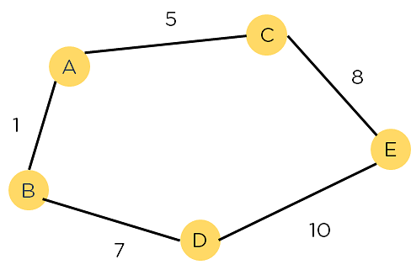
Figure 1: Weighted Graph
A major drawback of the algorithm is its space and time complexity. It takes a large amount of space to store all possible paths and a lot of time to find them.
[Related reading: Top 45 Data Structure Interview Questions and Answers for 2022]

Applications of A* Algorithm
The A* algorithm is widely used in various domains for pathfinding and optimization problems. It has applications in robotics, video games, route planning, logistics, and artificial intelligence. In robotics, A* helps robots navigate obstacles and find optimal paths. In video games, it enables NPCs to navigate game environments intelligently. Route planning applications use A* to find the shortest or fastest routes between locations. Logistics industries utilize A* for vehicle routing and scheduling. A* is also employed in AI systems, such as natural language processing and machine learning, to optimize decision-making processes. Its versatility and efficiency make it a valuable algorithm in many real-world scenarios.

Why A* Search Algorithm?
A* Search Algorithm is a simple and efficient search algorithm that can be used to find the optimal path between two nodes in a graph. It will be used for the shortest path finding. It is an extension of Dijkstra’s shortest path algorithm (Dijkstra’s Algorithm). The extension here is that, instead of using a priority queue to store all the elements, we use heaps (binary trees) to store them. The A* Search Algorithm also uses a heuristic function that provides additional information regarding how far away from the goal node we are. This function is used in conjunction with the f-heap data structure in order to make searching more efficient.
Let us now look at a brief explanation of the A* algorithm.

Explanation
In the event that we have a grid with many obstacles and we want to get somewhere as rapidly as possible, the A* Search Algorithms are our savior. From a given starting cell, we can get to the target cell as quickly as possible. It is the sum of two variables’ values that determines the node it picks at any point in time.
At each step, it picks the node with the smallest value of ‘f’ (the sum of ‘g’ and ‘h’) and processes that node/cell. ‘g’ and ‘h’ is defined as simply as possible below:
- ‘g’ is the distance it takes to get to a certain square on the grid from the starting point, following the path we generated to get there.
- ‘h’ is the heuristic, which is the estimation of the distance it takes to get to the finish line from that square on the grid.
Heuristics are basically educated guesses. It is crucial to understand that we do not know the distance to the finish point until we find the route since there are so many things that might get in the way (e.g., walls, water, etc.). In the coming sections, we will dive deeper into how to calculate the heuristics.
Let us now look at the detailed algorithm of A*.

